**Coin98 Token**

**What is Coin98 Token (C98 Token)?**

C98 Token is the native utility token of the Coin98 DeFi platform, powering the entire ecosystem. C98 tokens are built on Ethereum, Binance Smart Chain (BSC), and Solana.

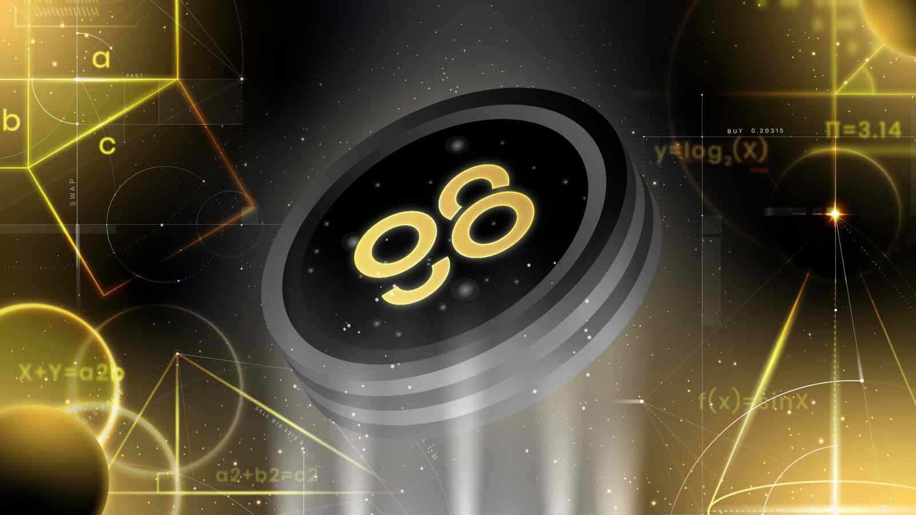

**Coin98 Token Use Cases**

Coin98 Token (C98 Token) plays an important role in operating the Coin98 ecosystem, and at the same time brings profits to holders and rights for long-term development.



Platform Service Fees

When using Coin98 Exchange, users are required to pay a small fee for each transaction successfully. This fee is paid using the native C98 token.

Staking Incentives

For Coin98 Exchange to function well, it is critical to incentivize users to play the role of liquidity providers and stake their digital assets into the decentralized market-making pools. As compensation for opportunity costs, by providing liquidity, or participating in liquidity mining across the various Coin98 staking options and platforms, users can earn a passive income by locking up funds and receiving C98 tokens in return.

Governance

To promote decentralized community governance for the network, C98 token holders may propose and vote on governance proposals to determine features and/or parameters of the Coin98 Exchange and its products. By participating in the platform’s governance model, users can commit C98 tokens to vote on new features and changes to various protocol parameters throughout the Coin98 crypto network.

For the avoidance of doubt, the right to vote is restricted solely to voting on features of the Coin98 Exchange; the right to vote does not entitle C98 token holders to vote on the operation and management of the Company, its affiliates, or their assets or the disposition of such assets to token holders, and does not constitute any equity interest in any of these entities. The arrangement is not intended to be any form of joint venture or partnership.

Unique Membership Rights

C98 Token holders are arranged into a tiered system that provides access to exclusive privileges and premium events, based on the amount of C98 held. Users in higher tiers will gain exclusive access to premium events and privileges, such as priority for Coin98 launchpad participation and marketing events with strategic partners.

Product Development and Growth

Furthermore, the C98 token will be used to create a “self-sustainable, closed-loop economy” through the collection of network fees, whether in C98 or otherwise, would be re-distributed as incentives for active contributors within the ecosystem, or set aside for future product development and ecosystem growth.

**C98 Token Metrics**

Specification:

* Token Name: Coin98
* Ticker: C98
* Blockchain: Ethereum, Binance Smart Chain, Solana
* Standard: ERC20, BEP20, SPL
* Max Supply: 1,000,000,000 C98
* Circulating Supply: 185,000,000 C98
* Allocation on-chains:
  + ETH: 50,000,000 C98
  + BSC: 100,000,000 C98
  + Solana: 35,000,000 C98

Smart Contract:

| ERC20 | 0xae12c5930881c53715b369cec7606b70d8eb229f |
| --- | --- |
| BEP20 | 0xaec945e04baf28b135fa7c640f624f8d90f1c3a6 |
| SPL | C98A4nkJXhpVZNAZdHUA95RpTF3T4whtQubL3YobiUX9 |

**C98 Token Allocation** 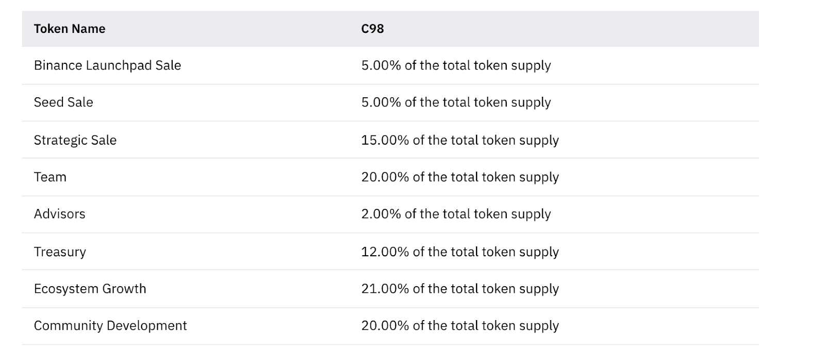

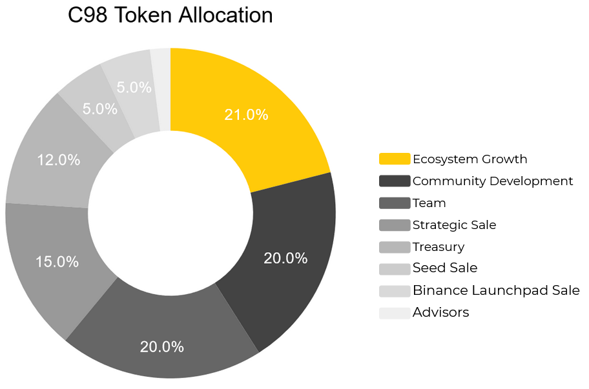

**C98 Token Release Schedule**

| Ecosystem Growth | 4 years vesting, 30% release at TGE (Token Generation Event), linear unlock starting from the 2nd year |
| --- | --- |
| Community Development | 4 years vesting, 30% release at TGE (Token Generation Event), linear unlock starting from the 2nd year |
| Team | 4 years vesting, 1 year cliff, linear unlock starting from the 2nd year. |
| Strategic Sale | 2 years vesting, 1 year cliff, linear unlock starting from the 2nd year. |
| Treasury | 4 years vesting, 10% release at TGE (Token Generation Event), 1 year cliff, linear unlock starting from the 2nd year. |
| Seed Sale | 3 years vesting, 1 year cliff, linear unlock starting from the 2nd year. |
| Binance Launchpad Sale | 100% release at TGE |
| Advisors | 3 years vesting, 1 year cliff, linear unlock starting from the 2nd year |

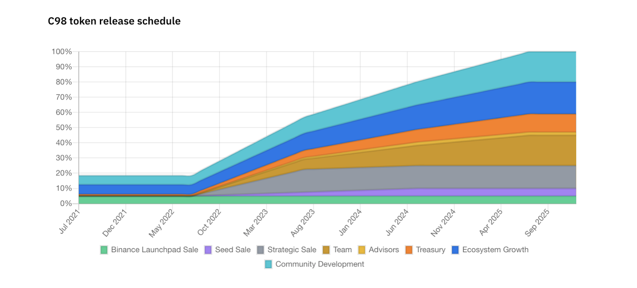

# **Audit**

C98 Token is audited thoroughly, along with due diligence by Binance before the IEO.

Check out our Audit Report here on Github: <https://github.com/coin98/coin98-token-contract/tree/master/audit_reports>

Smart Contract Audit Report: <https://github.com/coin98/coin98-docs>